Design Document

The games project folder is listed under: Branch “UnityStuff” under ‘Prototype1’

Jessica Hon - storytelling

Sabelo Nkwanyana - Coding

Ariana Jacpasad - Art

Hypothesis

Our prototype is based on the game *Storyteller* (<https://www.youtube.com/watch?v=JQMlHokAQRg>). It is a game which focuses on the narrative that is created through drag and drop mechanics. These games are also known as comic-book-style games.

Process

1. We began by gathering inspiration for our game by assessing the types of games each of us enjoys playing at current - some examples include; *Wytchwood* and *Bear and Breakfast.* However, we decided to focus on the narrative aspects and not the environment, crafting or building.
2. We assigned roles to ourselves: Sabelo to coding, Ariana to art and Jessica to story making.
3. Once each of us completed our tasks, we compiled the work together to form this prototype.

The aim of this game was for the player to place the sprites in the order they see fit to tell a story that made sense. If placed in the correct order the character sprites will react accordingly. The puzzle element comes from the player trying to figure out what the correct order of things is with simple sprites and will only know they’re moving in the right direction through the character's reactions to what is happening in that scene.

For prototype one we wanted to get the basics of the game which were the click and drop into the scene, the short stories, and the scenes. These comic book games often have the characters reacting with small pop-up reactions to show their emotions or sound, the characters also react to their placements in the scene.

One of the issues we faced was how to fit more than 3 scenes equally on the screen. With discussion from the group, the options were either an edge scroll based on the mouse position or a scroll rect transform. This entails that when a button is clicked the camera will move to the next panel for the next scene but still show the previous scene. In the end, we decided to go with using the keys to scroll left and right, the A and D keys respectively.

For the art, pixel art was decided on as it fits the feel of the game. When looking at different comic-style games, the animations were small jumps. Two types of character designs were made, one small and simple (reminiscent of *Kindergarten)* and the other one is a more detailed pixel art that was ultimately chosen by the 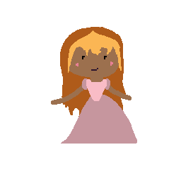group.

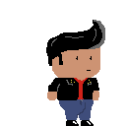

Versus

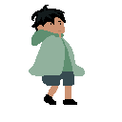

Reflection

At first, the game looked simple and easy to make but the more we thought through how to make it the small details that make this game style interesting were slowly becoming an issue. For example, we had to brainstorm between the 3 of us on how to even do the set-up scenes. We decided on using more than one panel and that can only accept one thing (The background panels can only have backgrounds placed in them and then once those are filled the characters can be placed). Another issue that was faced was the clear indication of the stories, as the artist, the story that fits this game style the best is the Romeo and Juliet story. The other story becomes a bit difficult to portray without more than one sprite, the different sprites will take away the puzzle element as it will become clear what the answer is instantly. One thing in the future I think as a group that should be changed is the stories, they seemed like a good idea in the beginning, but they soon become difficult and too complicated for this gameplay.